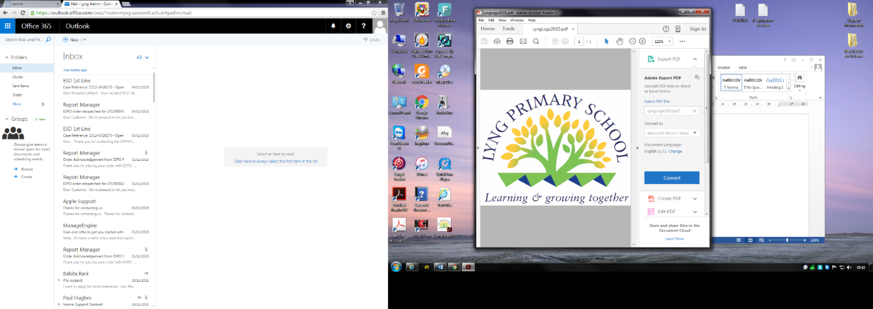

# Mental Health and Emotional Wellbeing

**Policy**

**Date Prepared:** September 2022

**Date Approved by Governing Body:** July 2022

**Date to be reviewed:** September 2025

Chair of Governors _______________________________ Date_______________________

This policy was written in consultation with staff, pupils, parents and professionals involved in mental health and wellbeing.

**Mission Statement**

At Lyng Primary School we are committed to supporting the emotional health and wellbeing of our staff, children and families.

By spotting the signs of ill health early, we can cultivate and grow hope for recovery.  Especially when early intervention is important by listening without judgement, we can grow the hope that someone who may be struggling with difficult experiences can feel accepted and understood.

We take the view that positive mental health is everyone’s responsibility and that we all have a role to play.

At our school we:

* help children to understand their emotions and feelings better
* help children feel comfortable sharing any concerns or worries
* help children socially to form and maintain relationships.
* promote self esteem and ensure children know that they count.
* encourage children to be confident and ‘dare to be different’
* help children to develop emotional resilience and to manage setbacks.

We promote a mentally healthy environment through:

* Promoting our school values and encouraging a sense of belonging.
* Promoting pupil voice and opportunities to participate in decision-making
* Celebrating academic and non-academic achievements
* Providing opportunities to develop a sense of worth through taking responsibility for themselves and others
* Providing opportunities to reflect.
* Access to appropriate support that meets their needs

We pursue our aims through:

* Universal, whole school approaches
* Support for pupils going through recent difficulties including bereavement.
* Specialised, targeted approaches aimed at pupils with more complex or long term difficulties including attachment disorder.

## Scope

This policy should be read in conjunction with our SEND policy in cases where pupils mental health needs overlap with these. This policy should also be read in conjunction with policies for Behaviour and Anti-bullying, PSHE, RHE and SEMH. It should also sit alongside child protection procedures.

## Lead Members of Staff

Whilst all staff have a responsibility to promote the mental health of students, staff with a specific, relevant remit include:

Mrs Wellings – DSL/SMHL

Mr Boughey – SEMH Lead/Learning Mentor

Miss Hartshorne – SENCO

## Teaching about Mental Health Wave 1 Appendix 2

The skills, knowledge and understanding needed by our students to keep themselves mentally healthy and safe are included as part of our developmental PSHE, RHE curriculum.

Commando Joe (+Tracker)

RSHE/PSHE Jigsaw Curriculum

Chico Time

LOTC

Edible Gardens

Forest School

Safe and calm environment

Mindfulness

Dog, Duck and Cat

SDQ’s

Reflection area

Play Leaders

School Council

Positive Classroom Management

Caught being kind in class

Newsletter

National Online safety and The Connected World curriculum

The specific content of lessons will be determined by the specific needs of the cohort we’re teaching but we will also use Jigsaw curriculum frame work to ensure that we teach mental health and emotional wellbeing issues in a safe and sensitive manner.

## Targeted support Wave 2

The school will offer support through targeted approaches for individual pupils or groups of pupils which may include:

Peer Mentors

Learning Mentor Support

Anger Management Intervention

Conflict Resolution Intervention

Worry boxes

Healthy Mind Happy Me

Nurture

Child line

Resilience Intervention

3 Houses/Wishes and Feelings

Bereavement

Young Minds

Lego Therapy

My Star

Draw and Talk

Boxall Profile

National Online safety

Targeted SDQ Intervention

The school will make use of resources to assess and track wellbeing as appropriate including:

* Strengths and Difficulties questionnaire
* The Boxall Profile

## Signposting Wave 3

We will ensure that staff, pupils and parents are aware of what support is available within our school and how to access further support.

## Please see Appendix 1 for child pathway

## Identifying needs and Warning Signs

All staff will monitor pupils and report on Cpoms, identifying a range of possible difficulties including:

* Attendance
* Punctuality
* Relationships
* Approach to learning
* Physical indicators
* Negative behaviour patterns
* Family circumstances
* Recent bereavement
* Health indicators

School staff may also become aware of warning signs which indicate a student is experiencing mental health or emotional wellbeing issues. These warning signs should always be taken seriously and staff observing any of these warning signs should communicate their concerns with the Senior Mental Health Leads. SEMH Lead as appropriate.

Possible warning signs include:

* Changes in eating / sleeping habits
* Becoming socially withdrawn
* Changes in activity and mood
* Talking or joking about self-harm or suicide
* Expressing feelings of failure, uselessness or loss of hope
* Repeated physical pain or nausea with no evident cause
* An increase in lateness or absenteeism

## Working with Parents

In order to support parents we will:

* Highlight sources of information and support about mental health and emotional wellbeing on our school website
* Share and allow parents to access sources of further support e.g. through parent forums Class Dojo.
* Ensure that all parents are aware of who to talk to, and how to get about this, if they have concerns about their child.
* Make our emotional wellbeing and mental health policy easily accessible to parents
* Share ideas about how parents can support positive mental health in their children.
* Keep parents informed about the mental health topics their children are learning about in PSHE, RHE and share ideas for extending and exploring this learning at home.

## Working with other agencies and partners

As part of our targeted provision the school will work with other agencies to support children’s emotional health and wellbeing including:

Kooth

Murray Hall

Kaleidoscope

Point of Access

GP

A+E

School Nurse

CAMHS

Edward Trust (Bereavement)

Inclusion Support (SEMH)

Barnardos

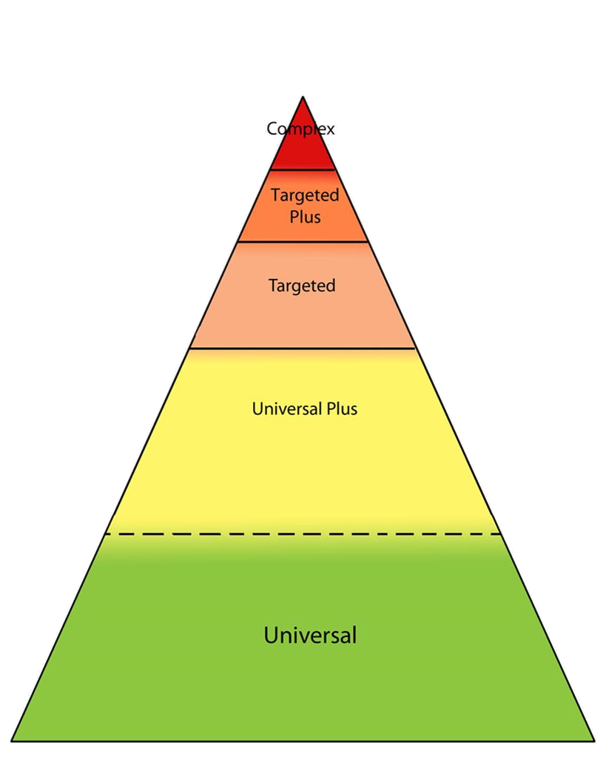

Safeguarding and Medical Intervention

Wave 4

Wave -3 External Support and safeguarding

Wave 2-3

Learning Mentor – Nurture

Wave 2 Learning Mentor group/1-1 sessions

Wave 1 Teaching and Learning

## Training

As a minimum, all staff will receive regular training about recognising and responding to mental health issues.

The MindEd learning portal provides free online training suitable for staff wishing to know more about a specific issue.

Training opportunities for staff who require more in depth knowledge will be considered as part of our performance management process and additional CPD will be supported throughout the year where it becomes appropriate due to developing situations with one or more pupils.

Appendix 1

Mental Health and Wellbeing Support In My School

**Wave 3**

**I may need a person outside of school who can help with my mental wellbeing and emotions because of something that may have happened to me or my family or I may find managing my emotions difficult**

Mrs Wellings Will arrange this for me, they may have to make sure I am safe too and will speak to my teachers, parent/carers and me. The adults around me may have to put a plan together to make sure I am safe because I am finding my behaviour and emotions hard to manage .

**Wave 2**

**If I need a little more help with my Mental Wellbeing I can see staff in school who will help me:**

Mr Boughey, Mrs Wellings, Miss Parveen, Mrs Howard

I may have interventions in learning how to manage my emotions and behaviour. These adults will also speak to my Parents/carers

My Parents/carers can contact these adults and my class teacher if they feel I may need a little more help with my emotions

We also have Peer Mentor who are trained to support me if I am worried about anything

**Wave 1**

**In school we learn to take care of our mental wellbeing by:**

Our PSHE Lessons planned by our class teacher

Chico Time, this is when I can share with my teacher and my class what is going well for me and if I am worried about anything, We also talk about what's happening in the world

We learn outside which includes: Edible Garden s, Forest School, we know is good for our wellbeing

Our School is Safe and calm environment, we learn

Mindfulness and use the reflection table to help us understand how we are feelings when we are struggling

I talk to a trusted adult

SDQ’s Reflection area

Play Leaders

School Council

Positive Classroom Management

Caught being kind in class Newsletter

Appendix 2

Lyng Primary School

Mental Health Waves of Support for children

Access to specialist support

**Wave 1**

Commando Joe (+Tracker) Respect Curriculum

RSHE/PSHE Jigsaw Curriculum

Chico Time LOTC Edible Gardens Forest School

Safe and calm environment

Mindfulness Dog, Duck and Cat, PE, Swimming

SDQ’s Reflection area

Play Leaders, Broad and balanced curriculum, Trips

School Council

Positive Classroom Management

Caught being kind in class Newsletter

**Wave 2**

Peer Mentors

Learning Mentor Support

Anger Management Intervention

Conflict Resolution Intervention

Worry boxes Healthy Mind Happy Me

Nurture Child line

Resilience Intervention

3 Houses/Wishes and Feelings

Bereavement Young Minds

Lego Therapy My Star

Draw and Talk

Boxall Profile NOS

Targeted SDQ Intervention

**Wave 3**

Kooth

Murray Hall

Kaleidoscope

Point of Access

GP

A+E

School Nurse

CAMHS

Edward Trust (Bereavement)

Inclusion Support (SEMH)

Prevention

Identification

and Early Support